Create a file with .txt extension (/home/ ). Change the permission set if that file, so that any user can read it, group can read/write & owner can read/write/execute it.

Solution:-

Created demo.txt file

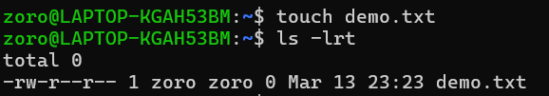

Granted permission

